Distributed Systems | Multiple interconnected computers that cooperate to provide some service  Why: Higher capacity & performance, Connect geographically separate systems, Build reliable, always-on systems  Challenges: System design & architecture, Fault tolerance, Consistency/correctness of distributed state, Performance, Security, Testing & debugging, …
Challenge 1) Failures: want to keep system doing useful work in presence of partial failures
2) Managing distributed state: - keep data available despite failures (make multiple copies)
- Make popular data fast for everyone (make multiple copies in diff places)
- Store huge amt of data (split into multiple partitions on diff machines)
Thought Experiment: 2-Generals Problem (no soln, prove by contradiction last msg can be removed)
Remote Procedure Call (RPC) | Client/server pattern  In single-host system  float balance(int acctID) {return balance[acctID]}  void deposit(int acctID, float amt) {  balance[acctID] += amt  return OK;}  client() {deposit(42, $50.00); print balance(42);} | For multiple hosts: need define a msg protocol  Client need set up socket, marshalling (package msg into protocol format)  Server need set up socket, unmarshalling (extract relevant data from msg protocol)
W RPC: compile protocol into stubs that do marshalling/unmarshalling. - Make a remote call look like a local fn call
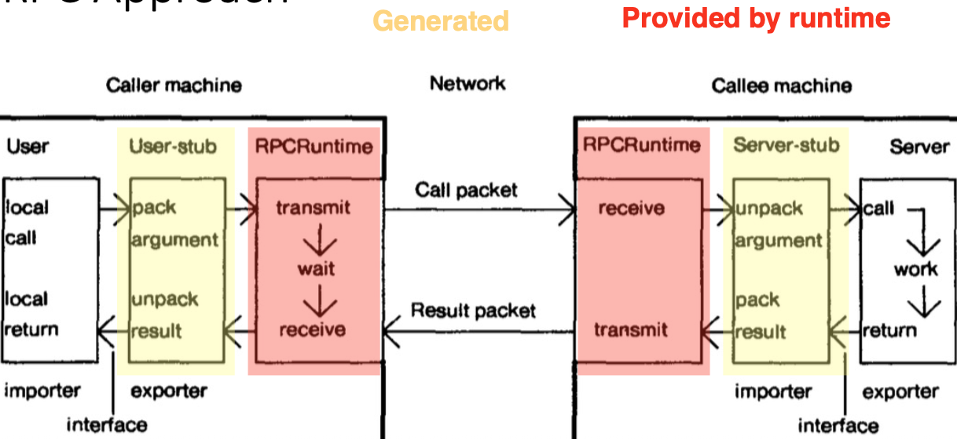
Client stub: marshal request type + args into buffer, send req to server, wait for reply, decode response, return result
Server: loop and wait for command, decode and unpack req params, call procedure, build reply msg containing results, send reply
With RPC, it hides complexity of remote messaging
client() {RPC_deposit(server, 42, $50.00); print RPC_balance(server, 42);}
Remote calls can fail: - Msgs dropped. - Client crash. - Server crash.
- Server crash after performing op but before reply. - Server appear to crash but is slow. - Network partitions
1) RPC semantics: at-least-once RPC
- Client retries request until it gets a response. - If operations are idempotent
2) at-most-once RPC
- Client includes a unique ID in every request. - Server keeps history of requests it has already answered, their ID, and result. - If duplicate, server resends result (and no re-execution)
a) Server never discards old RPCs
b) Unique client IDs, per-client RPC sequence num. Client includes "seen all replies ≤ X" w every RPC (safe to delete)
c) Only allow client 1 outstanding/in-flight RPC at a time. Arrival of seq+1 allows server to discard all ≤ seq
3) Exactly-once RPC
- At-most-once + client retries until success
- Not possible in general as what if server crashes. How to know whether crash before or after executing

Time & Clocks in Distributed Systems | 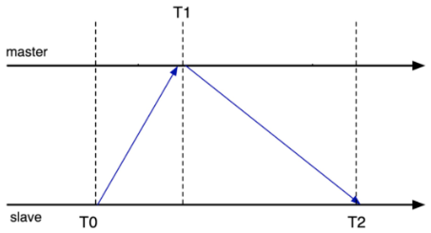  1) Physical clocks: synchronization  - Beacon-based approach. - Designate server w GPS/atomic clock as master. - Master periodically broadcasts time  - Clients receive broadcast, reset their clock. - Still have network latency  2) Interrogation-based protocols  - Client queries server. - Time = T1 + (T2 - T0)/2  - Multiple samples, average over several servers; throw out outliers  - Take into account clock rate skew. - NTP, PTP
Happens-before r/s | Captures logical (causal) dependencies btw events. (Irreflexive) partial ordering: $→$.  1) a $↛$ a. 2) If a $→$ b, then b $↛$ a. 3) If a $→$ b, and b $→$ c, then a $→$ c
In Distributed Systems: Processes/Nodes, Messages, Events
1) Within a process, a comes before b, then a $→$ b
2) If a = send(M), and b = recv(M), then a $→$ b
3) Transitivity: if a $→$ b and b $→$ c , then a $→$ c
Note: a $↛$ b DOES NOT mean b $→$ a
If a $↛$ b and b $↛$ a: a and b are concurrent (no one can tell whether a or b happens first)
Logical clocks | Way to assign timestamps to events: preservers happens-before r/s  If a $→$ b, then C(a) < C(b)  Clock conditions: 1) If a and b are on the same process i, and a comes before b, then C_{i}(a) < C_{i}(b)  2) If a = process i sends M, and b = process j receives M, then C_{i}(a) < C_{j}(b)
Keep a local clock T. - Increment T whenever an events happens
- Send clock value on all messages as T_{m}. - On message receipt: T = max(T, T_{m}) + 1
Total ordering | If C(a) < C(b), then a $⇒$ b. - When C(a) == C(b), use a tiebreaker (e.g. process ID)  If a $→$ b, then a $⇒$ b. BUT converse not true, a $⇒$ b DOES NOT mean a $→$ b
Mutual exclusion | Use clocks to implement a lock. - Only 1 process has lock at a time. - Grant the lock in request order (fairness).  - Requesting processes eventually acquire the lock (no starvation)  Assumptions: - In-order point-to-point msg delivery. - No failures
Ea msg carries a timestamp T_{m}
3 msg types: request (broadcast); release (broadcast); acknowledge (on receipt)
Ea node's state: queue of request msgs, ordered by T_{m}. - Latest timestamp it has received from ea node
a) On receiving a request: - Record msg timestamp; - Add req to queue; - Send an ack
b) On receiving a release: - Record msg timestamp; - Remove corresponding req from queue
c) On receiving an ack: - Record msg timestamp
a) To acquire the lock: - Send req to everyone, including self
b) Lock is acquired when: - my req is at head of my queue AND - I've received higher-timestampd msgs from everyone = so my request must be the earliest
c) To release lock: - Send release to everyone, including self
Issue w Lamport Clock | If a $→$ b, then C(a) < C(b) BUT converse not true: If C(a) < C(b) does not mean a $→$ b (could be concurrent)  - Lamport clock cannot be use as global order, as would induce some unnecessary ordering constraints  A better logical lock: 1 where converse is true (If C(a) < C(b) then a $→$ b), i.e. a $→$ b iff C(a) < C(b)  - There might still be concurrent events (neither C(a) < C(b) or C(b) < C(a))  - Soln: Vector clocks
Vector clocks | Clock is a vector C, length = num of nodes. E.g. (0,0,0) for 3-node system  On node i, increment C[i] on each event | On receipt of msg w clock C_{m} on node i:  - increment C[i]  - for ea j != i: { C[j] = max(C[j], C_{m}[j]) }  E.g. node 0 (4,5,2) receive msg (2,7,0) = (5, 7, 2)
Compare vectors elem by elem
If C_{x}[i] < C_{y}[i] and C_{x}[j] < C_{y}[j] for some i, j = then C_{x} and C_{y} are concurrent
If C_{x}[i] ≤ C_{y}[i] for all i, and $∃$ j s.t. C_{x}[j] < C_{y}[j] = then C_{x} happens before C_{y}

Distributed State |  | Distributed State = info retained in 1 place that is determined by something, somewhere else in the system  Benefits: Performance, Reliability, Coherence
Client-side caching: - Reduce load on a bottleneck service (exploit locality)
- Better latency: cache more conveniently located & hopefully faster
High-level view: - caching = move data to where we want to use it
- RPC = move computation to where the data is
NFS | NFS file system's approach: Design philosophy = simplicity  "Stateless": - all essential info kept on file server's disk  -- can still cache in server memory, but cannot depend on cache for correctness  - servers do not cache client information  Idempotent operations: - read & write at offset. - lookup
NFS Update Protocol (write-through cache): - When client writes to a file: -- updates local cache
-- sends write request to server, -- server writes data to disks
Issues: 1) Performance: every client write request synchronously writes to server disks
2) Consistency: - other client caches not notified of updates, - read inconsistent data
- NFS solution: - periodic polling (by client), - eventually receive updates
Sprite File System | Sprite: Unix-like distributed OS from Berkeley  Server tracks opened file state: - which clients are reading/writing which files  - open()/close() need to contacct the server  Server uses "write-back cache": - modified blocks are kept in memory, - writes back to disk after 30s
Consistency: - Server knows which clients are reading/writing a file
- If only 1 client opens a file: -- client don't synchronously send updates to server, -- writes back to server after 30s
- If multiple clients open a file, and ≥ 1 is writing: -- all reads and writes go through server (not cacheable)
 | Pros: - Consistency, - Performance. Cons: - Complexity, - Durability & recovery
Other approaches | - Invalidation: writer invalidates all other cached copies  - Write-update: writer updates all other cached copies
Consistency |  | We say Sprite provides better consistency than NFS  Consistency: the allowed semantics (return values) of a set of operations to a data store or shared object  A safety property: specifies the "bad things" that shouldn't happen in any execution  Not a liveness properties: specifies the "good things: that should happen in every execution  Consistency properties specify the interface, not the implementation: data might be replicated, cached, disaggregated, …  Anomaly: violation of the consistency semantics
Strong consistency: system behaves as if there's just a single copy of the data
- Implementation details like caching and replication are invisible to clients
Weak consistency: allows behaviors significantly diff from the single store model
Eventual consistency: the aberrant behaviors are only temporary
1) Performance: - consistency requires synchronization/coordination when data is cached/replicated
- Often slower to make sure you always return the right answer
2) Availability: - what if client is offline, or network is not working
- Weak/eventual consistency may be the only option
3) Programmability: - weaker models are harder to reason against
Some notations | Suppose there is a single register (think hashmap with only 1 key)  Processes issue RPCs to read or write a value.  - w(a) = send write req to register to update value to a. - r -> a = send read req to register, and receive value a  The initial request starts at time t and reply returns at some later time t + x
Sequential Consistency |  | Sequential Consistency: requires that a history of operations be equivalent to a legal sequential history, where a legal sequential history is one that respects the local ordering at each node  - real (physical) time across processes do not determine ordering  Aka serializability when applied to transactions
Linearizability |  | Linearizability = sequential consistency + respects real-time ordering  - If e₁ ends before e₂ begins, then e₁ appears before e₂ in the sequential history  -- If they are concurrent, any order is ok  - Linearizable data structures behave as if there's a single, correct copy  -- 1 of the strongest guarantees for concurrent objs
Sequential Consistency vs Linearizability |  |  | Sequential consistency allows operations to appear out of real-time order  - Most common way systems are sequentially consistent but not linearizable is by allowing read-only operations to return stale data
Weaker Consistency |  | 1) Causal Consistency:  Writes that are not concurrent (i.e. writes related by the happens-before relation) must be seen in that order. Concurrent writes can be seen in diff orders on diff nodes  - Linearizability implies causal consistency
2) FIFO Consistency:
Writes done by the same process are seen in that order; writes by diff processes can be seen in diff orders
 |  | 3) Eventual Consistency ≈ if all writes to an object stop, eventually all processes read the same value

Primary Backup Replication | Simple: 2 servers.  At a given time: - Clients talk to 1 server (primary). - Data replicated on primary and backup  - If primary fails, backup becomes primary  Goals: - Correct and available (as if a single HA server). - Despite some failures
Basic operation: - Client sends operations (Put, Get, Append) to primary
- Primary decides order of ops. - Primary forwards seq of ops to backup
- Backup performs ops in same order (hot standby) OR backup just saves log of operations (cold standby)
- After backup has executed/saved ops, primary replies to client
Challenges: - Non-deterministic operations. - State transfer btw primary & backup (log of ops? content of memory?)
- Strong consistency. - Dropped msgs. - Server failures.
- There can be only 1 primary at a time: clients, primary, backup need to agree
View Service | View server decides who is primary and backup  - Clients and servers depend on view server. - View server is a single point of failure  - Must be only 1 primary at a time. - Don't communicate w view server on every request
View = statement about the current roles in the system (who is primary & backup). - Views form a seq in time
Ea server periodically pings (Ping RPC) view server
To view server, node is - dead if missed n Pings; - alive after a single Ping
Any num of servers can send Pings. View server maintains set of alive servers
If > 2 servers are live (primary + backup), extra are "idle"
- Idle servers can be promoted to backup/primary
On primary failure: - View server declares a new "view", moves backup to primary
- View server promotes an idle server (if any) as new backup
- New Primary initializes new backup's state. - Now ready to process ops
- Other scenarios to declase new "view": 1) Backup fails. 2) View has no backup initially, now have idle server
How to ensure new primary has up-to-date state? Only promote backup to primary
But idle server can become primary at startup
What if backup hasn't gotten state yet? And new primary dies? 1st thing to do: transfer state to backup
Soln: View server waits for primary ACK
- Track whether new primary has acked (w ping) the current view
- Must stay w current view until ACK (even if primary seems to have failed). - Another weakness of this protocol
More than 1 server might think it is primary at the same time: Split brain
But only 1 server can ACT as primary: act as = respond to clients
Rules | 1) Primary in view i+1 must have been backup or primary in view i  - New primary might not know previous state  2) Primary must wait for backup to accept/execute each op before replying to client  - Missing writes (primary writes, backup didn't, client try read from backup, but write is missing)  - Stale reads (A, B: A still up but can't reach view server; B, C: client1 writes to B, client 2 reads from A, A returns outdated value)  - Reads treated at state machine operations too (must be forwarded to backup)  3) Backup must accept forwarded requests only if view is correct  - Partially split brain: (A, B: A forwards request; B, C: which arrives here; C, D: but by then maybe C is new primary)  4) Non-primary must reject client requests  - Inconsistencies: (B, A: Outdated client sends req to A [client thinks view is A, B])  - Old msgs to primary (A, B -> A, D: Outdated client sends req to A [client thinks view is A, B]) = still ok  5) Every operation must be before or after state transfer  - Atomic state transfer  -- Until new backup is up to date: there is a window of vulnerability (if new primary crashes, state lost)  -- Hence, need to do state transfer quickly: simpler to implement if no concurrent ops
Cases when system can't make further progress (i.e. process new client requests)
- View server fails. - Network fails entirely. - Client can't reach primary but can ping VS
- No backup and primary fails. - Primary or backup fails before completing state transfer
 | State transfer must include RPC data (which client command was processed already)

FLP: impossibility of consensus |  | Impossible for a deterministic protocol to guarantee consensus in bounded time in an asynchronous distributed system (even w only 1 faulty process)  Paxos: non-blocking as long as a majority of participants are alive, provided there is a sufficiently long period w/o further failures
Paxos | Set of proccesses that can propose values. - Processes can crash and recover.  - Asynchronous communication via msgs (msgs can take arbitrarily long to be delivered)  - Msgs can be lost and duplicated, but not corrupted  - Goal: consensus on a single value
1) Proposers: propose values (proposals) to be chosen
2) Acceptors: accept/reject propostals. - Collectively decide when a value is chosen
3) Learners: once a value is chosen, learn the decided value
3 roles above are only logical roles, i.e. multiple roles can co-locate on the same physical node
The game: Consensus | Safety: - Only a value that has been proposed can be chosen. - Only a single value is chosen  - A process never learns that a value has been chosen unless it has been  Liveness: - Some proposed value is eventually chosen. - If a value is chosen, a process eventually learns it
Terminology | 1) Value: a possible value/operation to reach consensus on  2) Proposal: to select a value; proposals are uniquely numbered  3) Accept: of a specific proposal/value  4) Chosen: proposal/value accepted by a majority  5) Learned: fact that proposal is chosen is known
Majority | Majority = more than half of participants  Majorities intersect: for any 2 majorities S and S', there is some node in both S and S'
Our Approach | Broad definition of consensus: - we should eventually choose a value. - We should only choose 1 value  Suppose only 1 value is proposed by a single proposer -> That value should be chosen  P1: An acceptor must accept the 1st proposal that it receives
Acceptors must (be able to) accept more than 1 proposal (as diff proposers can propose diff values)
To keep track of diff proposals, assign a natural num to ea proposal
- Proposal is then a pair/tuple (psn, value). - Diff proposals have diff psn. - Diff proposals can have same value
- A proposal is chosen when it has been accepted by a majority of acceptors
- A value is chosen when a proposal w that value has been chosen
- Proposal nums must be unique and infinite -> Assign ea proposer an infinite slice, i.e. Proposer i of N gets i, i + N, i + 2N, …
Need to guarantee that all chosen proposals result in choosing the same value
P2: If a proposal w value v is chosen, then every higher-numbered proposal that is chosen has value v
P2a: If a proposal w value v is chosen, then every higher-numbered proposal accepted by any acceptor has value v
P2b: If a proposal w value v is chosen, then every higher-numbered proposal issued by any proposer has value v
If a proposer p wants to issue a proposal numbered n: 2 cases:
1) A proposal (n', v) w n' < n is chosen -> Can only propose (n, v) = must be same value
- In every majority set S of acceptors, at least one acceptor has accepted (n', v)
2) No such proposal has been chosen -> Can propose any value (n, _)
- If there is a majority set S where no acceptor has accepted (or will accept) a proposal w num less than n, then p can propose any value
P2c: For any v and n, if a proposal w value v and num n is issued, then there is a set S consisting of a majority of acceptors s.t. either:
- no acceptor in S has accepted any proposal numbered less than n OR
- v is the value of the highest-numbered proposal among all proposals numbered less than n accepted by the acceptors in S
To maintain P2c, a proposer that wishes to propose a proposal numbered n must learn the highest-numbered proposal w num less than n, if any, that has been or will be accepted by ea acceptor in some majority of acceptors
- Avoid predicting the future by extracting a promise from a majority of acceptors not to subsequently accept any proposals numbered less than n
Paxos | Phase 1: prepare  A proposer chooses a new n and sends <prepare, n> to a majority of acceptors  If an acceptor receives <prepare, n'> where n' > n of any <prepare, n> to which it has responded, then it responds to <prepare, n'> with  - a promise not to accept any more proposals numbered less than n'  - the highest numbered proposal (if any) that it has accepted
Phase 2: accept
If the proposer receives a response to <prepare, n> from a majority of acceptors, then it sends to ea <accept, n, v> where v is either:
- the value of the highest numbered proposal among the responses
- any value if the responses reported no proposals
If an acceptor receives <accept, n, v>, it accepts the proposal unless it has in the meantime responded to <prepare, n'> where n' > n
Learning chosen values
Once a value is chosen, learners should find out about it. Diff strategies:
1) Ea acceptor informs ea learner whenever it accepts a proposal
2) Acceptors inform a distinguished learner, who informs the other learners (for optimization, so even if 0, 1, 2 DL, doesn't matter)
Because of failures (msg loss and acceptor crashes), a learner may not learn that a value has been chosen
- Learner can ask any proposer to propose something. Proposer can run paxos again to find what was chosen
FLP | 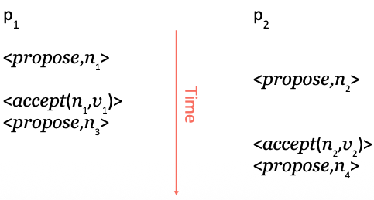  Liveness: progress is not guaranteed  Possible soln: Elect a distinguished proposer

SMR (state machine replication) protocol: PMMC | Paxos made moderately complex  High-level idea: - Leader elects itself by running Paxos Phase 1 for all instances  - Once elected, only runs Paxos Phase 2 for ea proposal  - If leader dies, other nodes repeat the process (elect themselves, etc.)  - Paxos ensures safety
Roles: 1) Replicas (like learners) = keep log of operations, state machine, configs
2) Leaders (like proposers) = get elected, drive the consensus protocol
3) Acceptors (same as Paxos acceptors) = "Vote" for leaders and accept ballots
Ballots = (leader, seqnum) pairs = isomorphic to proposal nums
Order: (0, 0) < (1, 0) < (2, 0) < … < (n, 0) < (0, 1) < (1, 1) < …
OR can write it as seq.leader: 0.0 < 0.1 < 0.2 < … < 0.n < 1.0 < 1.1
Acceptors | Acceptor: State = 1) ballot_num: NULL. 2) accepted: []  Leader1 -> Acceptor: p1a(0.1). Acceptor -> Leader: p1b(0.1, []). - Promise to accept ballot 0.1, then send ACK  Leader0 -> Acceptor: p1a(0.0). Since Acceptor ballot_num = 0.1 > 0.0 -> Reject p1a(0.0). Acceptor -> L0: p1b(0.1, [])
L1 -> Acceptor: p2a(<0.1, 0, A>) = <ballot_num, slot num, value in slot>. Slot num = index to insert value in accepted
For Acceptor: if 0.1 == curr ballot_num -> Accept. Then state = ballot_num: 0.1. accepted: [<0.1, 0, A>]
Acceptor -> L1: p2b(0.1)
state = ballot_num: 0.1. accepted: [<0.1, 0, A>]
L0 -> Acceptor: p2a(<0.0, 0, B>). Since 0.0 < 0.1: Acceptor ignore proposal. Acceptor -> L0: p2b(0.1)
Ballot nums increase. - Only accept values from curr ballot
If a value v is chosen by a majority on ballot b, then any value accepted by any acceptor in the same slot on ballot b' > b has the same value
Leaders Election | State = active: false. ballot_num: 2.0. proposals: []  active: true = distinguished proposer in Paxos. - Can have many leaders, but only 1 active leader at a time  Leader to get elected: send to all Acceptors p1a(2.0, [])
Case 1: majority/any of Acceptors reply with p1b(2.1, []), i.e "preempted"
Since 2.1 > 2.0, L0 should not be the active leader. L1 is the active leader
So L0 increase its ballot_num: 3.0
Case 2: majority of Acceptors reply with p1b(2.0, [])
L0: active: true
Case 3: Acceptor1 reply w p1b(2.0, [<1.1, 1, A>]). Acceptor2 reply w p1b(2.0, [<1.2, 1, B>]
Since 1.2 > 1.1 and both for slot 1, then L0 state: active: true, ballot_num: 2.0, proposals: [<1, B>]
Stable Leader:
Leader should try to get elected: - At beginning of time. OR - When curr active leader seem to have failed
- Curr active leader broadcasts HeartBeat msgs
- If leader gets preempted, don't immediately try for election again
Leader: handling proposals | Leader0 state: active: true, ballot_num: 0.0, proposals: []  Replica -> L0: Op1 should be A (Operation at slot 1 should have value A)  L0 state: active: true, ballot_num: 0.0, proposals: [<1, A>]  Since L0 is active leader: L0 send to all acceptors: p2a(<0.0, 1, A>)
Case1: majority of acceptors reject L0 proposal, i.e. "preempted"
L0 state: active: false, ballot_num: 0.0, proposals: [<1, A>]
Case2: majority of acceptors ok with L0 proposal
L0 to all replicas: Op1 is A
- Leaders should only propose 1 value per ballot and slot
- If a value v is chosen by a majority on ballot b, then any value proposed by any leader in the same slot on ballot b' > b has the same value
Replicas | State: [Op1, Op2, Op3, Op4, Op5, Op6, …]. E.g. [A, E, G, B]. slot_out = 3, slot_in = 5  Indexes < slot_out: all operations accepted  slot_out ≤ Indexes < slot_in: has been proposed but not accepted yet  slot_in ≤ Indexes: slots for new proposals
Case1: Leader -> Replica: decision(3, G)
Replica state: [A, E, G, B]. slot_out = 4, slot_in = 5
Case2: Leader -> Replica: decision(4, P)
Replica -> Leader: propose(5, B), B previously at 4, and slot_in = 5
Replica state: [A, E, G, P, B]. slot_out = 5, slot_in = 6
Problems w Paxos | - Hard to understand. - Multi-Paxos protocol not well specified  - Seperate proposers, acceptors, learners: -- doesn't match SMR system deployment, -- PMMC has same issue
Other SMR protocols |  |  | Raft, Viewstamped Replication. - (Basically) equivalent to Multi-Paxos
SMR protocol 2: Raft |  | High-level idea: - Only 1 role = server. - 3 states = Leader, Follower, Candidate  - Centered around an operation log. - 2 main protocols = Leader election & Log replication
Leader |  | Similar to distinguished proposer in Paxos and active leader in PMMC  - Only leader handles client requests and replicates them to followers
Leader election |  | Divides time into terms: - Consecutive integers = term 1, 2, 3, …  - Similar to proposal nums and ballot nums  Each term begins w an election  At most 1 server will win the election in a term. OR not leader gets elected  Ea server stores the curr term num (that they observed)  - Ignore msgs w lower term num. - Update when observe higher term num
Servers begin as followers. - Leader sends periodic heartbeat msgs
- If follower receives no msgs from leader over a timeout period: starts election
1) Follower increments curr term, transitions to candidate state
2) Votes for itself, and issues RequestVote RPC to all other servers
3) Server can only vote for at most one candidate in a term: first-come-first-served
4) Candidate wins if receives majority votes
5) Transitions to leader state
Votes can be split: no majority = no leader for the term
Candidate will timeout -> Start a new election: increment term num, send RequestVote, …
How to deal w split votes: Randomized timeouts
Log replication |  | Leader serves client requests. Appends req to its log. Issues AppendEntries RPC to all followers  After entry is stored on majority of replicas (including self). Applies operation to state machine  Retries RPCs indefinitely until all followers respond
Follower's logic |  | AppendEntries includes the index (and term num) of the log entry that immediately precedes the new entries  Follower rejects the request if doesn't have that entry  Otherwise appends new entries to log and responds to leader  Implication: no holes in the log
F1: [A, B]. L: [A, B]. F2: [A]
Client send L C to slot 3: F1: [A, B]. L: [A, B, C]. F2: [A]. L sends to all F (2, C)
Since F1 has entry at slot 2: F1: [A, B, C]. L: [A, B, C]. F2: [A], and F1 send ok
Since F2 don't have entry at slot 2: reject Leader's request (2, C)
L on receive F2 rej: sends F2 (1, BC)
F1 send L ok: F1: [A, B, C]. L: [A, B, C]. F2: [A, B, C],
Log commit |  | After leader replicates an entry on a majority of server:  Log entry is committed: Entry is durable = no other command will be chosen at the same index  All prior entries in log are also committed  Safe to execute commands to the commit point
Log divergence |  | If there is only 1 term (and 1 leader), then all logs will be consistent  - Some follower may lag behind, but never diverge  Leader changes may result in divergence
To re-establish log consistency:
- Leader forces follower to duplicate its log
- Leader overwrites follower's conflicting entries
Procedure:
1) When receives AppendEntries, follower deletes any conflicting entry (and all entries that follow it), and reject AppendEntries
2) Leader retries AppendEntries w a lower index
3) Eventually all conflicting entries are removed, and leader's entries are installed
Leader election revisited |  | Requirement: leader must have all the committed log entries when elected  - Committed entry is present in at least one of the servers in a majority set  In a majority set of servers, the one with the most "up-to-date" log contains all the committed entries  - log w later term is more "up-to-date"  - if ends w same term, longer log = more "up-to-date"  Rejects RequestVote if own log is more up-to-date than candidate

Transactions | Group a set of individual operations (reads and writes) into an atomic unit  ACID: Atomicity (all or nothing), Consistency, Isolation (concurrency), Durability (transaction effects are persisted)  Technique: write-ahead logging (WAL)  - Write ea operation (and its effects) into a log on disk  - Write commit record that makes all ops commit  - Only tell client op it's done after commit record written  - After a crash, scan log and redo any transaction w a commit record; undo any without
Consistency in ACID ≠ linearizability, sequential consistency, …
But that changes within a transaction are consistent w application constraints (CHECK …)
Isolation: all transactions run in a "isolated" env
Diff levels: - strict serializability, - serializability, - snapshot isolation, …
Simplest: only run 1 transaction at a time
Standard (better) option: two-phase locking (2PL)
Distributed transactions are hard: - data might be stored on diff nodes (might ea be replicated or cached)
- Need to coordinate ordering of operations across copies of data
 | Atomicity: either all participating nodes execute the transaction (commit), or none of them execute (abort)
Atomic commit protocol (ACP) | Every node arrives at the same decision – Safety  Once a node decides, it never changes – Safety  Transaction committed only if all nodes vote Yes – Safety  In normal operation, if all processes vote Yes, the transaction is committed – Safety  If all failures are eventually repaired, the transaction is eventually either committed or aborted – Liveness  3: Tx commit -> All nodes vote yes  4: All nodes vote yes -> Tx committed  All vote yes but abort: OK for 3, but NOT OK for 4  Some vote no but commit: NOT OK for 3, but OK for 4
Two phase commit (2PC) | 1 instance of atomic commit protocol  Role: 1) Participants: nodes that must update data relevant to the transaction  2) Coordinator: node responsible for executing the protocol  RPCs: PREPARE = Can you commit this tx? COMMIT = Commit this tx. ABORT = Abort this tx
 | Coordinator send PREPARE to all -> All send yes to coordinator -> Coordinator send COMMIT to all -> All commit
If participant vote No, can immediately abort
Coordinator then send to participants who votes Yes to abort
Participant fail before sending response
Participant recover: check log -> Know it didn't send response -> Abort
Coordinator timeout and send ABORT to participant who send yes
Participant fail after sending yes
Participant recover -> check log -> Know it send Yes -> WAIT (participant in uncertainty period)
Coordinator send COMMIT to all
Participant fail after sending yes, but vote is lost (didn't reach coordinator)
Participant recover -> check log -> Know it send Yes -> WAIT (participant in uncertainty period)
Coordinator timeout and send ABORT to participants who vote yes
Participant who fail timeout and send DECISION? to coordinator and learns tx is ABORT
Coordinator send PREPARE -> All send Yes -> Coordinator fail
Coordinator recover -> check log -> Know it has not send decision yet -> Abort
OR
Coordinator recover -> check log -> Know it has not send decision yet -> send PREPARE again -> repeat process
Coordinator send PREPARE -> All send Yes -> Coordinator write Yes decision to log -> Send COMMIT to 1 -> Coordinator fail
Coordinator recover -> Some participants timeout and send DECISION? -> Coordinator check log -> Know it has Yes decision -> Send back to participants COMMIT
Coordinator send PREPARE -> All send Yes -> Coordinator write Yes decision to log -> Send COMMIT to 1 -> Coordinator fail
Coordinator recover after a long time -> Some participants timeout and send DECISION? to other participants involved in the tx to learn decision
Coordinator send PREPARE -> All send Yes -> Coordinator fail
Some participants timeout and send DECISION? to other participants involved in tx.
Since no decision made by coordinator yet -> NO participants can commit/abort -> All wait for coordinator to recover
Isolation and Two Phase Locking | Similar to consistency guarantees in Distributed systems  Terminology: isolation levels  Usual definition: serializability  Each tx's reads and writes are consistent w running them in a serial order, 1 tx at a time  To provide isolation: concurrency control protocols
2PL | 2 types of locks: 1) read-lock: shared lock. 2) write-lock: exclusive lock  Acquire and release locks in 2 phases:  - expanding phase: locks are acquired and no locks are released  - shrinking phase: locks are released and no locks are acquired  Usually: only release locks after transaction is committed/aborted
Lock(R, A): acquire read lock on A -> Unlock(A)
Lock(W, B): acquire write lock on B -> Unlock(B)
Technically called strong strict 2-phase locking (SS2PL)
 | 2PL ensures serializability -> Expanding phase ensure no conflict between txs
Strict Serializability | Similar to linearizability = Serializability + real-time constraints  If T1 begins after T2 commits (in real time), T1 is ordered after T2  2PL ensures strict serializability
Weaker isolation levels | Weaker levels of consistency: causal consistency, eventual consistency, ...  Can also have weaker levels of isolation  These allow various anomalies: behavior not consistent w executing serially  - snapshot isolation, repeatable read, read committed, …
Other concurrency control protocols | Optimistic concurrency control (OCC)  Timestamp ordering (TO)  Multiversion concurrency control (MVCC)  …
2PL in distributed txs | Basically the same  Send req to participating shards to acquire read and write locks  - Can merge w PREPARE request in two-phase commit  Release locks when tx commits/aborts  What happens if cannot acquire lock? Wait OR abort  How about deadlock/livelock?
Durability | Tx effects persist after commit, even in case of system  Single node DB: WAL and persistent storage  What if disk fails?  Replicate DB using Paxos  Distributed DB? replicate ea shard
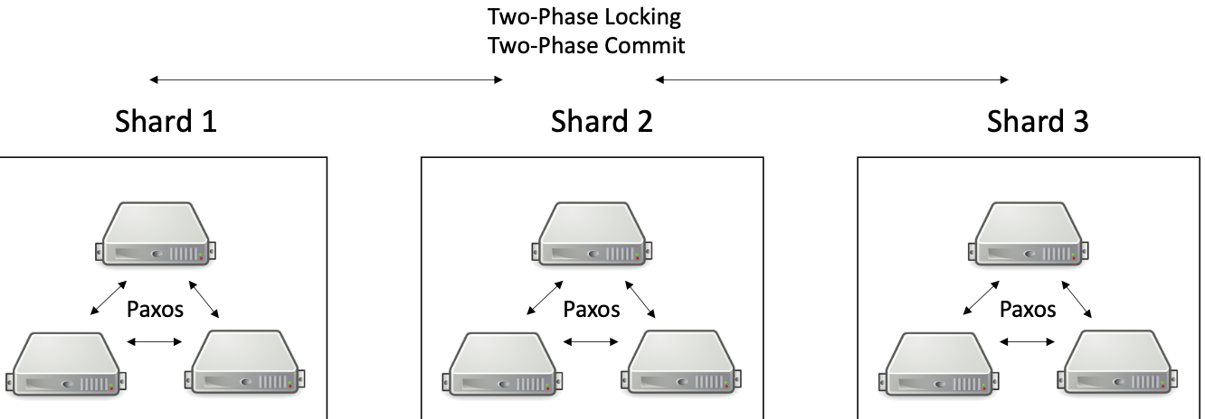
Paxos to guarantee Durability
2PC for Atomicity
2PL for Isolation

Distributed Txs | Partition DB / key-value store into multiple shards  Ea shard is stored on a diff storage server  Why partitioning? - storage capacity, - scalability  But still want ACID properties. Soln: distributed txs. - E.g. MySQL Cluster, Google's Megastore and Spanner
Google's Spanner | 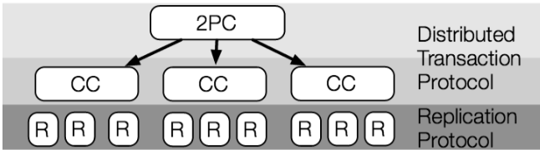  Ea shard is stored in a Paxos group:  - replicated across data centers  - has a (relatively long-lived) leader  Leader of ea group tracks read/write locks (for 2PL)  Txs span Paxos groups using 2PC  - 1 group leader becomes the 2PC coordinator, others participants
During execution, client reads objects from shards
- contact the appropriate Paxos group leader, acquire read locks
- buffer writes locally
- implication: reads in a transaction do not see its writes
Client decides to commit, sends PREPARE to all participants (leader)
- participant leader acquires write locks
- Paxos-replicate a PREPARE log entry
- vote either OK or Abort, reply to coordinator
If coordinator receiveds OK from all participants
- Paxos-replicates a COMMIT log entry
- replies the client, and sends COMMIT msg to all participant leaders
Participant leader
- Paxos-replicates COMMIT log entry
- applies all writes
- releases all locks
Lab 4 | Similar to Spanner  Coordinator drives 2PC  Don't need to send separate READ requests  READs can be done during PREPARE
Distributed Txs are expensive | To avoid transactional overheads:  1) Weaker consistency/isolation: - need to deal w inconsistencies and anomalies  2) Read-only txs w/o locking: - Spanner: use physical clock  - Expose the uncertainty in the clock value  - Read at a particular time (including the "current time")
Lab 4 | Overview:  - Build a linearizable, sharded key-value store w txs and dynamic load balancing  - Part 1: ShardMaster for managing system configurations  - Part 2: Sharded KV store and handles moving shards  - Part 3: Distributed txs
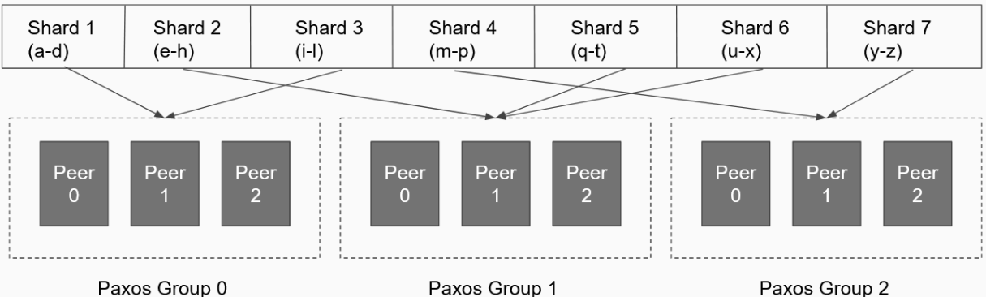
Terminology:
1) Shard:
- subset of keys.
- key -> shard mapping deterministic
2) ShardStoreServer:
- handles key-value store for the assigned shard.
- replicated using Paxos
3) Configuration:
- similar to a view in lab 2.
- which Paxos groups responsible for which shards
- monotonically increasing config num
4) Shard Master:
- "Application" replicated by Paxos
- service that responds to changes in config
ShardMaster
- Keeps track of which groups serve which shards
- Remember all old configs
- 4 commands: Join, Leave, Move, Query
- Join, Leave, Move create new config
- Join and Leave: -- divide the shards as evenly as possible. - move as few shards as possible
Reconfiguration
- Do reconfigurations 1 by 1
- Don't process client requests during reconfiguration
- For part 2: -- All Paxos replicas shouold perform client requests and reconfiguration operations in the same order
-- Paxos-replicate reconfig operations too

- Receive new config from ShardMaster
- Paxos-replicate new config
- Send shards to groups responsible for the shard in the new config: Recipient groups should ACK
- Receive shards from groups responsible for your new shards: Send ACKs
- Wait until receiving all new shards and ACKs for old shards
- Need to decide what to put in the Paxos log
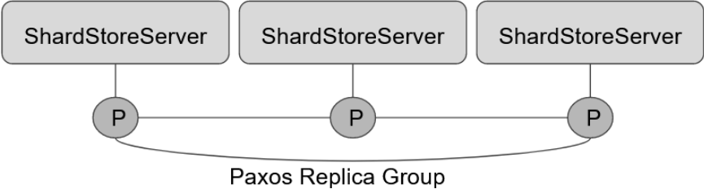
ShardStoreServer
- P = Paxos subnode
- ShardStoreServer & its subnode communicate through handleMessage
- Operations are replicated using Paxos
- ShardStoreServer executed replicated operations in the decided order
 | 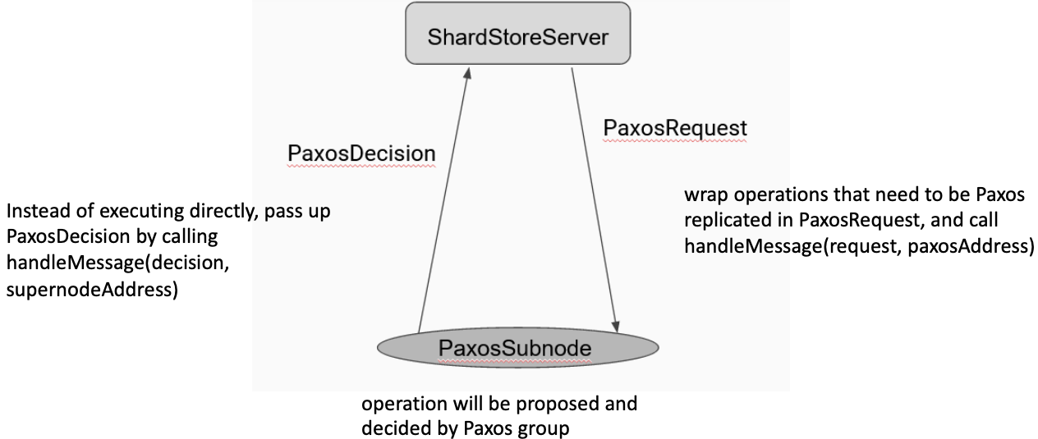

Chubby |  | Distributed coordination service. - Open-source equivalent: Apache ZooKeeper  Goal: allow client apps to synchronize and manage dynamic config state. E.g. view service, lock service  - Fault-tolerant, available, strongly consistent  - Intuition: only some parts of an app need consensus  - Implementation: multi-Paxos state machine replication
Chubby's interface |  | Like a file system. Chubby provides: small files, locking, "sequencers"  API: - Open, Close. - GetContents, SetContents, Delete. - Acquire, TryAcquire, Release  - Get Sequencer, SetSequencer, CheckSequencer
E.g. x = Open("/ls/service/primary") # Predefined fixed path
if (TryAcquire(x) == success) { SetContents(x, my-address) }
else { primary = GetContents(x) }
 |  | Client then contact Chubby to find who is Primary, then send req to Primary
SMR performance |  | Client req -> Leader. Leader p2a -> Replicas. Replicas p2b -> Leader. Leader execute + reply -> Client  Latency = 4 message delays. Leader is also throughput bottleneck
Performance optimizations |  |  | 1) Batching: - Master accumulates reqs from many clients  - Does 1 round of Paxos to commit all to log  - Big throughput gains at expense of latency  -- classic systems trick, e.g. disk,  --ubiquitous in systems w/o latency requirements
2) Partitioning: run multiple Paxos groups, ea responsible for diff keys
- Throughput scales w num of groups: uniform request dist
- How to handle cross-group operations?
3) Read optimization: leases
- Most requests are reads. So want to avoid communication on reads
-- Communication not needed for durability. -- Just need to ensure amster hasn't changed
- Optimization: master gets leases, renewed while up
-- Chubby: ≈ 10s
-- Master can process reads alone if holding lease (no need replicate to others)
-- If master fails, need to wait 10s before new master can respond to requests
4) Caching
- Chubby use client caching heavily: file data, file metadata
- Strong consistent, write-through (write applied to cache & storage vs write-back), write-invalidate cache
-- Master tracks which clients might have file cached
-- Sends invalidations on update
Reads during invalidation:
1) SetContents(f) -> Chubby sends invalidate(f) to ALL clients w cached f -> After ALL clients ACK -> Chubby SetContents done
So even if read happen before invalidation arrives, read and SetContents are concurrent, so linearizability preserved
2) Clients cannot install a copy in their cache during invalidation (otherwise liveness problem, where chubby need to keep invalidating newer copy, as invalidation not ACK by all)
Client failures |  | Clients hold file handles, locks, and cached data. If client holding a lock/file cache fails:  - KeepAlive RPCs btw clients and Chubby  - Another form of lease  - When lease expires: locks are released, empties and disables cache
Proxies |  | KeepAlives and invalidations are a huge % of load  Use proxies to track state for groups of clients  - To master, proxies act like clients  - To clients, proxies act like master
Google File System (GFS) | Workload: - reads (small random and large streaming reads)  - writes: many files written once; other files appended to. Small random writes very rare
GFS interface: app-level library, not a POSIX file system
- create, delete, open, close, read, write: concurrent writes not guaranteed to be consistent
- record append: guaranteed to be atomic
- snapshots
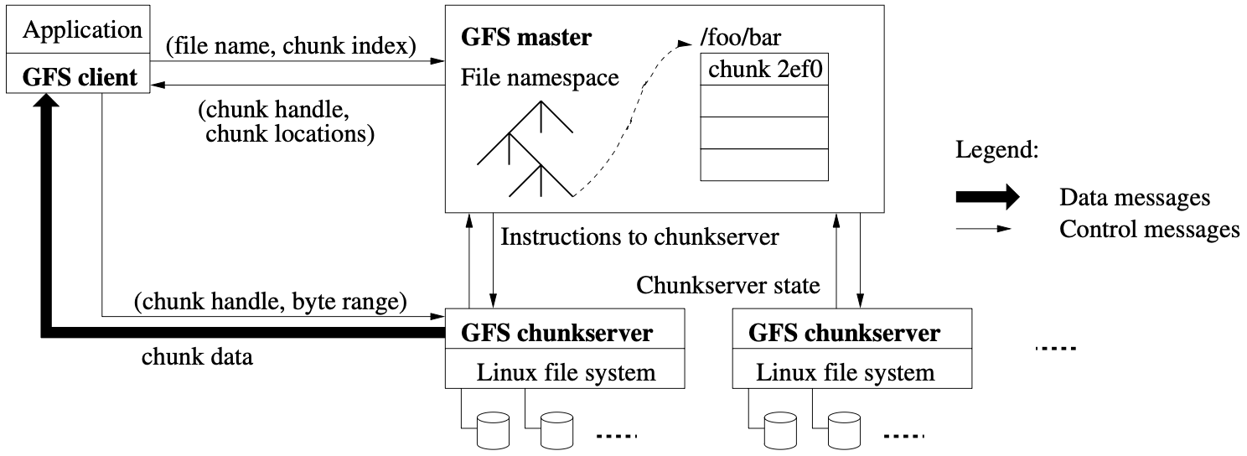
GFS architecture:
- each file stored as 64MB chunks
- ea chunk on 3+ chunk servers
- "single" master stores metadata
-- paxos replicated
"Single" master architecture
Master stores metadata: - file name -> chunk list. - chunk ID -> list of chunkservers holding it
All metadata stored in memory (≈64MB/chunk)
Never stores file contents
Actually a replicated system using shadow masters
For Read Operations
GFS client - (file name, chunk index) -> GFS master
GFS master - (chunk handle, chunk locations) -> GFS client
Client - (chunk handle, byte range) -> GFS chunkserver
Chunkserver - (chunk data) -> GFS client
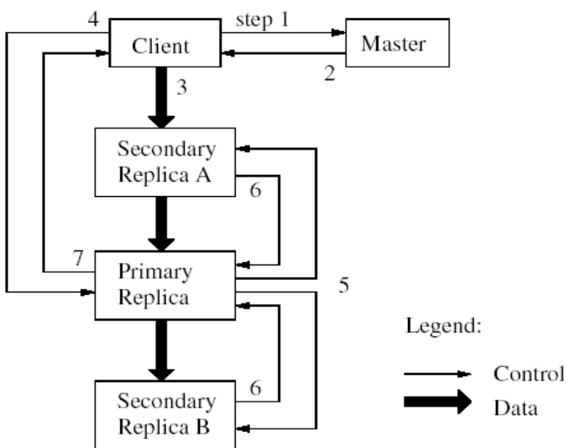
For write operations
1) Client -> Master
2) Master -> Client (nearest replica + Primary)
3) Client -> Replica (data to write)
3) Replica forwards to other replicas …
4) Client -> Primary (write my data)
5) Primary replica -> replicas (ask them to commit)
6) Replicas -> Primary ACK
7) Primary -> Client ACK
GFS file region state after mutation (can have 3 diff possible states):
1) Consistent: all clients see the same data (might be undefined, some parts of write lost)
2) Defined: Consistent and clients see the mutation in its entirety
3) Inconsistent: clients may see diff data at diff time
When writes fails:
Errors encountered at replicas reported to client
Client request considered failed
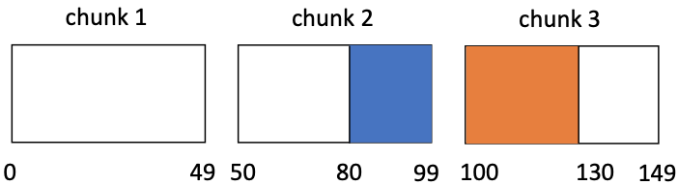
State after successful writes: Concurrent writes from clients
All finished w/o failures
State is consistent. Might not be defined
Client 1: write(f, buf, pos=80, size=50)
Client 2: write(f, buf, pos=80, size=50)
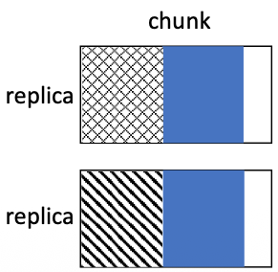
Atomic Record Append
- Try to append at end of last chunk
- If append would exceed chunk size: -- pads the chunk to max size (all replicas)
-- asks client to retry
- If fails at any replica: client retries
- After successful append: -- file region where successful append writes to is defined
-- intervening regions are inconsistent
Dealing with inconsistencies
- Most apps mutate files by appending
- Each record contains checksum: -- validity of record can be verified. -- handles paddings and incomplete write
- Add unique identifiers: handles duplicates

CAP | In a distributed data store, impossible to simultaneously achieve all three of:  1) Consistency: linearizability  2) Availability: every request received by a non-failing node must result in a response  3) Partition tolerance: network can lose arbitrarily many messages btw 2 nodes
Dynamo | Amazon's HA distributed key-value store  - Eventual consistency: Can have stale reads, Can have multiple "latest" versions, Reads can return multiple values  - Not sequentially consistency
get: key -> ([value], context)
- exposes inconsistency: can return multiple values
- context is opaque to user (set of vector clocks)
put: (key, value, context) -> void
- caller passes context from previous get
Resolving conflicts in app | Apps can choose how to handle inconsistency:  - Shopping cart: take union of cart versions  - High score list: take max score  Default: highest timestamp wins  Context used to record causal r/s btw gets and puts:  - Once inconsistency resolved, should stay resolved  - Implemented using vector clocks
Dynamo's vector clocks | Ea obj associated w a vector clock: e.g. [(node1, 1), (node2, 3)]  Ea write/put has a coordinator, and is replicated to multiple other nodes: - in an eventually consistent manners  Nodes in vector clock are coordinators
Client sends clock w put (as context)
Coordinator increments its own index in clock, then replicates across nodes: for now, return after replicating to majority (will modify later)
Nodes keep objs w conflicting (concurrent) vector clocks: these are then returned on subsequent gets
If clock(v1) < clock(v2), node deletes v1
Read from majority (modify later)
Vector clock returned as context w get: Merge of all returned objects' clocks
Used to detect inconsistencies on write
Replication in Dynamo | 3 params: N, R, W  N = num of nodes ea key replicated on  R = (min) num of nodes participating in ea read  W = (min) num of nodes participating in ea write  Data replicated onto N nodes: but responds to client after contacting W  Reads see values from R nodes  Common config: (3, 2, 2)
Dynamo "sloppy" quorum | Want GET to see most recent PUT (as often as possible)  Quorum: R + W > N. - Don't wait for all N. - R and W will (usually) overlap  What if some replicas not reachable? need availability  Ea key has a list of possible replicas > N  Never block waiting for unreachable nodes: Try next node in list (might be a node that is not responsible for that key)
Replication in Dynamo | Coordinator sends ea request (put or get) to 1st N reachable nodes in the list  - Wait for R replies (for read) or W replies (for write)  Normal operation: gets see all recent versions  Failures/delays: - Writes still complete quickly. - Reads eventually see
Ensuring eventual consistency | What if puts end up far away from 1st N?  - Could happen if some nodes temporarily unreachable  - Server remembers "hint" about proper location  - Once reachability restored, forwards data  Nodes periodically sync whole DB
Where does ea key live? | Keys are partitioned/sharded. How to assign keys to servers?  Goals: - Balance load, even as servers join and leave  - Minimize work when config changes. - No centralization
Proposal 1: Hashing | For n nodes, a key k goes to hash(k) mod n  Hash distributes keys uniformly. But if add a node: need to redistribute a lot of keys
Proposal 2: Consistent Hashing | 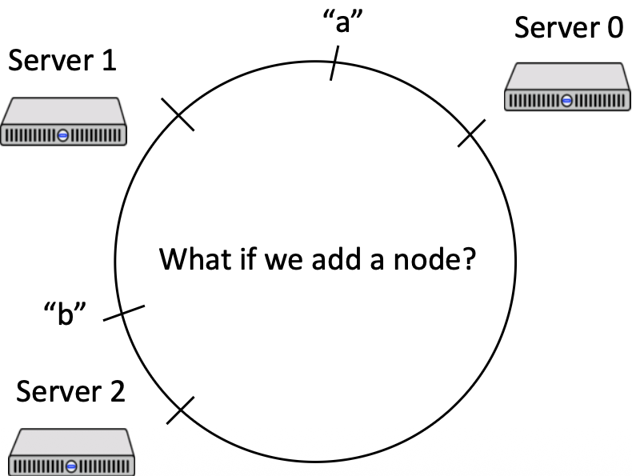  1) Hash the node ids  2) Keys are hashed, go to "next" node  E.g. "a' to 0, "b" to 1  Suppose add Server 4 btw "b" and Server 1  Only "b" has to move  On avg, K/n keys move btw 2 nodes

Byzantine Fault Tolerance | Failure models:  - Fail-stop/crash failures: node either executes protocol correctly or just stop  - Byzantine faults: faulty nodes can take arbitrary actions. Can send any msgs, collude w ea other, ... in attempt to "trick" the non-faulty nodes and subvert the protocol
 | Hardware failures can cause crash and abnormal behavior. - Security vulnerabilities can let attackers into distributed systems
BFT state machine replication: - same state mmachine replication model as Multi-Paxos, Raft, Viewstamped replication
- Assume f replicas are (Byzantine) faulty
- Then total need 3f + 1 servers (f Byzatine, f Paxos)
Paxos: quorums of f+1 out of 2f+1 nodes
- Majority, Quorum intersection: any 2 quorums intersect at at least 1 node
BFT: quorum of 2f+1 out o f3f+1 nodes
- Quorum intersection: any 2 quorums intersect at at least 1 non-faulty node
Practical BFT (PBFT) | Progresses through a series of views  Single primary associated w ea view: equivalent to a leader  Client sends their commands to the primary  Primary assigns the command a seq num (slot num) and forwards to the backups
Case: faulty node impersonates other nodes
Solution: public-key cryptograph
- Servers and clients sign msgs and verify signatures. - Signatures aren't forgeable
- Anyone can verify signature. - Denote msg m signed by p as <m>_{p}
Private key + hash(plaintext) = signature
Public key + signature + hash(plaintext) = authentication (boolean)
Case: primary sends wrong results to client
Solution: all replicas send replies directly to client
- Client wait for f+1 matching replies
Case: primary assigns diff commands to same seq num (aka equivocation)
Soln: replicas exchange info about ops received from primary
- to make sure primary isn't equivocating
Case: primary ignores clients altogether, or other ways to prevent progress
Soln: backups can replace a faulty primary w a view change protocol
- when timing out committing client ops
Faulty clients: - assume there is some existing way for clients to authenticate themselves w the system
- Access controls can be used to restrict what ea client is allowed to do
- System admins can revoke access for faulty clients
PBFT | 3 sub-protocols:  1) Normal operations: i) Phase 1: Pre-prepare. ii) Phase 2: Prepare. iii) Phase 3: Commit  2) View change  3) Garbage collection
Pre-prepare | Client c sends m = <REQUEST>_{c}  Primary p sends <<PRE-PREPARE, v, n, D(m)>_{p}, m> to all backups  Primary assigns order of operations  v = view num. n = seq num assigned by primary. D(m) = digest of the msg (to reduce amt of public key crypto)  Backup accepts PRE-PREPARE if: - client req is valid  - backup is in view v. - Backup hasn't accepted a diff PRE-PREPARE for the same seq num in the same view
Prepare | Once backups accept the PRE-PREPARE, they broadcast PREPARE msgs to Primary and other backups  Prepare msg: <PREPARE, v, n, D(m)>_{i} (for server i)  Once a server has received 2f matching PREPAREs and the associated PRE-PREPARE  It has a Prepare Certificate
Prepare Certificate:
Goal: there exists no other prepare certificates w a diff command (for same view and same seq num)
2f+1 matching PRE-PREPARE and PREPARES guarantees that by Quorum intersection (at least 1 honest server)
Honest servers don't prepare diff commands in the same slot
Server CANNOT execute command after getting a Prepare Certificate
- Other servers may not have the same Prepare Certificate
- (Remaining) honest servers may not outnumber faulty servers
- Thus might not have enough info to pick the correct command
Commit | Once a server has a Prepare Certificate, it broadcasts a COMMIT msg <COMMIT, v, n, D(m)>_{i}  Once server has 2f+1 matching COMMITs (and the associated client msg), it has a Commit Certificate  Server can then execute command (provided it executed all previous commands) and reply to the client  <REPLY, v, t, i, r>_{i}
Commit Certificate:
- Proves that every quorum of 2f+1 servers has at least 1 non-faulty node w a Prepare Certificate
- Command is now stable and will be fixed in the same slot (even in future view changes)
View Change | Backups monitor primary. If primary stops responding to pings or backups timeout executing requests, start view change  View change: move to view v+1 and new primary  Goal: all committed commands carried over to new view  Trick: gather info from 2f+1 servers. If command is committed, a Prepare Cert is present at at least 1 of the 2f+1 servers
<VIEW-CHANGE, v+1, P, i>_{i}
New primary broadcast <NEW-VIEW, v+1, V, O>_{p}
Servers send VIEW-CHANGE msgs to new primary in view v+1
VIEW-CHANGE includes all Prepare Certs
New primary gathers 2f valid VIEW-CHANGE msgs
Broadcasts a NEW-VIEW msgs, which includes
- PRE-PREPARE msgs in view v+1 for ea prepared command in 2f+1 VIEW-CHANGE msgs
- All 2f+1 VIEW-CHANGE msgs
Backups verify NEW-VIEW, and enter new view
- Send Prepare for the PRE-PREPAREs
Costs | Extra round of communication adds latency  Committing a single operation requires O(n²) msgs  Cryptography operations are slow

